**Scheduling**

**Assumptions:**

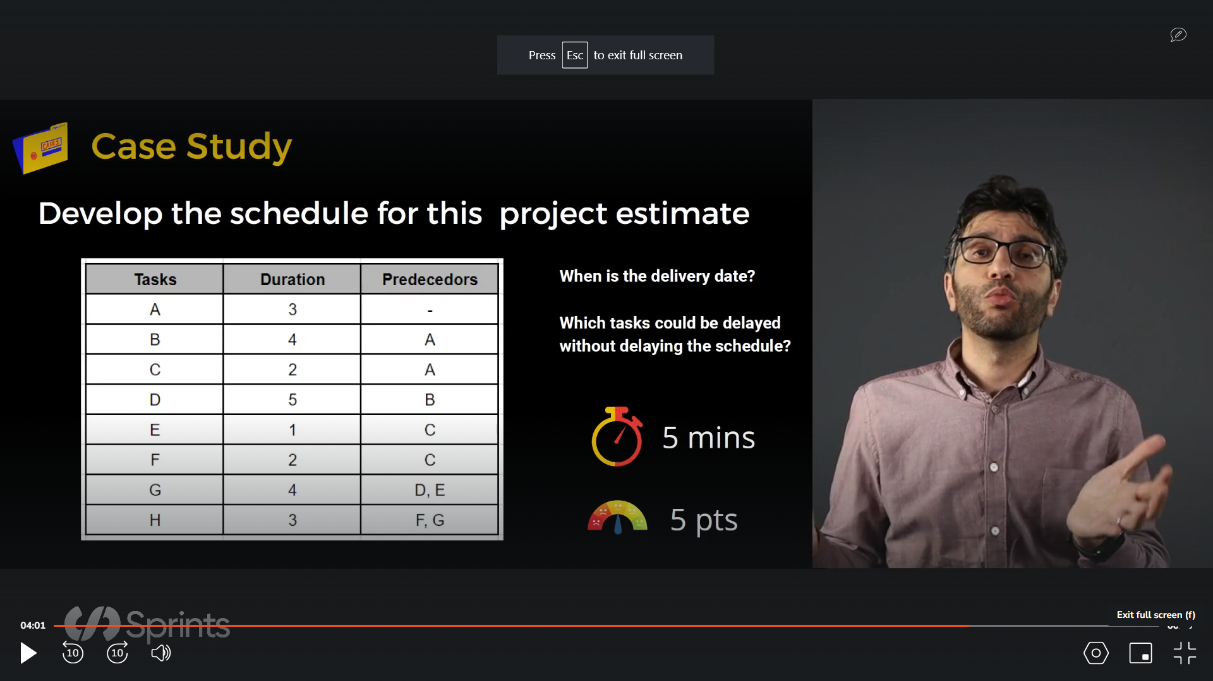

|  |  |  |  |  |  |  |  |  |  |  |  |  |  |  |  |  |  |  |  |
| --- | --- | --- | --- | --- | --- | --- | --- | --- | --- | --- | --- | --- | --- | --- | --- | --- | --- | --- | --- |
| A |  | | |  |  |  |  |  |  |  |  |  |  |  |  |  |  |  |  |
| B |  |  |  |  | | | |  |  |  |  |  |  |  |  |  |  |  |  |
| C |  |  |  |  | |  |  |  |  |  |  |  |  |  |  |  |  |  |  |
| D |  |  |  |  |  |  |  |  | | | | |  |  |  |  |  |  |  |
| E |  |  |  |  |  |  |  |  |  |  |  |  |  |  |  |  |  |  |  |
| F |  |  |  |  |  |  | |  |  |  |  |  |  |  |  |  |  |  |  |
| G |  |  |  |  |  |  |  |  |  |  |  |  |  | | | |  |  |  |
| H |  |  |  |  |  |  |  |  |  |  |  |  |  |  |  |  |  | | |
| DAYS | 1 | 2 | 3 | 4 | 5 | 6 | 7 | 8 | 9 | 10 | 11 | 12 | 13 | 14 | 15 | 16 | 17 | 18 | 19 |

Total number of days are 19 days

Tasks C, E, and F can be delayed